FINAL REPORT
Technova Software Hackathon – 2026

Project Title : VIRTUAL CLASSROOM WHITEBOARD AND COLLABORATION TOOL
Team Name : PIXEL BLOOM
Team Lead : Aparna S(7376252IT114)
Team Member: Bavana J.K (7376252IT123), Deepasree S(7376252IT135),Balamithra D (7376251CS130)

Introduction
The purpose of the Virtual Classroom Whiteboard and Collaboration Tool is to provide an interactive online learning environment where teachers and students can communicate, collaborate, and learn effectively. The system integrates a collaborative whiteboard, organized learning resources, participation tracking, and real-time communication to improve the online learning experience.
Problem Statement
Existing virtual classroom platforms primarily support online meetings but lack efficient collaboration, organized learning resources, permanent whiteboard storage, and effective participation tracking. Students find it difficult to revise specific topics, while teachers have limited insights into student engagement. The proposed Virtual Classroom Whiteboard and Collaboration Tool addresses these challenges by providing a collaborative workspace, searchable whiteboard history, structured learning resources, participation analytics, and a reward-based learning environment to improve the overall online learning experience.

Proposed Solution
Teachers can:
- Create virtual classrooms
- Schedule classes
- Start collaborative whiteboard sessions
- Upload study materials
- Save whiteboard after class
- Share notes with students
- Monitor student participation
Students can:
- Join virtual classrooms
- Collaborate on the whiteboard
- Draw, write, and annotate in real time
- View saved whiteboards
- Download notes
- Participate in discussions
Administrator can:
- Manage users
- Manage classrooms
- Monitor platform usage
- Manage announcements
- Maintain system security

Objectives
The objectives of the project are:
- Develop an interactive virtual classroom platform.
- Enable real-time collaborative whiteboard.
- Preserve whiteboard content after every class.
- Improve teacher-student collaboration.
- Allow students to revisit previous sessions.
- Provide a responsive and user-friendly interface.
- Reduce dependence on external collaboration tools.
System Analysis
Existing System | Proposed System
Video meetings only | Interactive virtual classroom
Whiteboard disappears after class | Whiteboard saved permanently
Manual note sharing | Automatic note storage
No revision support | Previous sessions available
Separate tools required | All-in-one platform

System Design & Implemenation
Technologies Used
The project was developed using modern technologies that support responsive design, efficient data handling, and scalable application development.
Frontend Technologies
- HTML5 for structuring web pages.
- CSS3 for designing responsive and visually appealing user interfaces.
- JavaScript for implementing client-side functionality.
- js for building reusable UI components and improving user interaction.
Backend Technology
- Node.js was used to develop server-side functionality and manage communication between the frontend and database.
Database
- MySQL stores user accounts, workspace details, booking information, and occupancy records.
UI/UX Design
- Figma was used to create wireframes, user interface designs, and interactive prototypes before implementation.
Development Tools
- Visual Studio Code for application development.
- Git and GitHub for version control and collaborative development.
- Postman for testing backend APIs.
Deployment
- Vercel for frontend deployment.
- Render for backend deployment.
- MySQL for cloud database hosting.
Project Modules
The application consists of several independent modules that work together to provide complete workspace booking functionality.
1. User Authentication Module

User Registration
User Login
Role-based Login (Teacher/Student)
Secure Authentication
User Profile
Logout
2. Virtual Classroom Module
- Create Classroom
- Join Classroom
- Schedule Classes
- Classroom Dashboard
- Attendance

3. Collaborative Whiteboard Module
- Real-time Drawing
- Pencil Tool
- Shapes
- Text Tool
- Color Selection
- Eraser
- Undo
- Redo
- Clear Board

4. Whiteboard Storage Module
- Save Whiteboard
- Load Previous Whiteboards
- Version History
- Download Notes
- Share Whiteboards
5. Resource Sharing Module
- Upload PDFs
- Upload Images
- Share Links
- Learning Materials
- Announcements
6. Discussion & Collaboration Module
- Live Chat
- Student Collaboration
- Teacher Announcements
- Group Discussions
7. Admin Module
- Admin Login
- Dashboard
- Manage Users
- Manage Classrooms
- View Reports
- Manage Announcements
- System Monitoring

Frontend Implementation
The frontend was developed using React.js along with HTML5, CSS3, and JavaScript to create a responsive, intuitive, and interactive user interface for both teachers and students.
Major Frontend Pages
- Splash Screen
- Login
- Register
- Dashboard
- Classroom
- Collaborative Whiteboard
- Saved Whiteboards
- Notes
- Profile
- Admin Login
- Admin Dashboard
Reusable React components were used to improve maintainability and reduce code duplication.

Backend Implementation
The backend was developed using Node.js
The backend performs:
- User Authentication
- Classroom Management
- Session Management
- Whiteboard Synchronization
- Real-time Collaboration
- Notes Storage
- File Upload
- Admin Operations
REST APIs and Socket.io enable seamless communication between the frontend and backend.

Database Implementation
MySQL stores:
- User Accounts
- Teacher Accounts
- Student Accounts
- Classroom Details
- Whiteboard Sessions
- Drawings
- Notes
- Uploaded Resources
- Chat Messages
- Attendance
- Saved Whiteboards
The database is designed for efficient retrieval and secure storage of classroom data.

Summary
The implementation successfully transforms the concept of an online classroom into a collaborative learning platform. Learnix combines real-time whiteboard collaboration, persistent note storage, resource sharing, and classroom management within a single application. The integration of React.js, Node.js, Mysql provides scalability, reliability, and an engaging user experience, enabling teachers and students to collaborate effectively before, during, and after every class

Proof:
Figma:
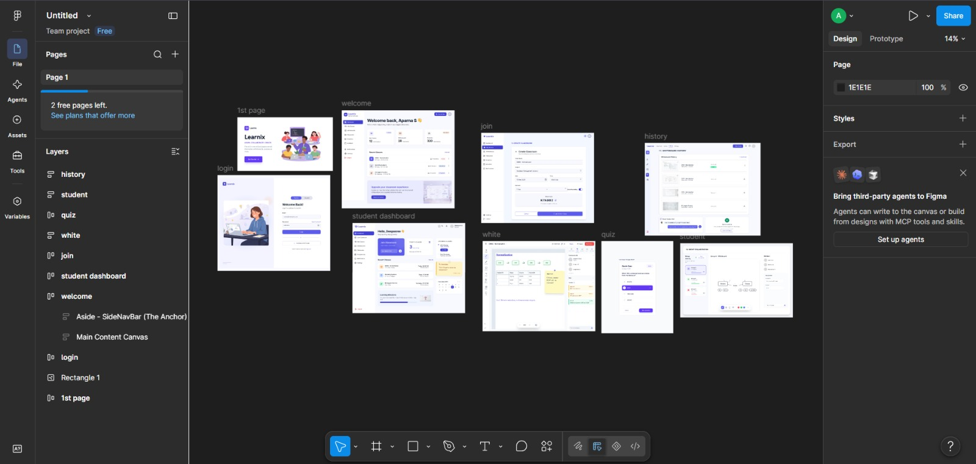

Frontend
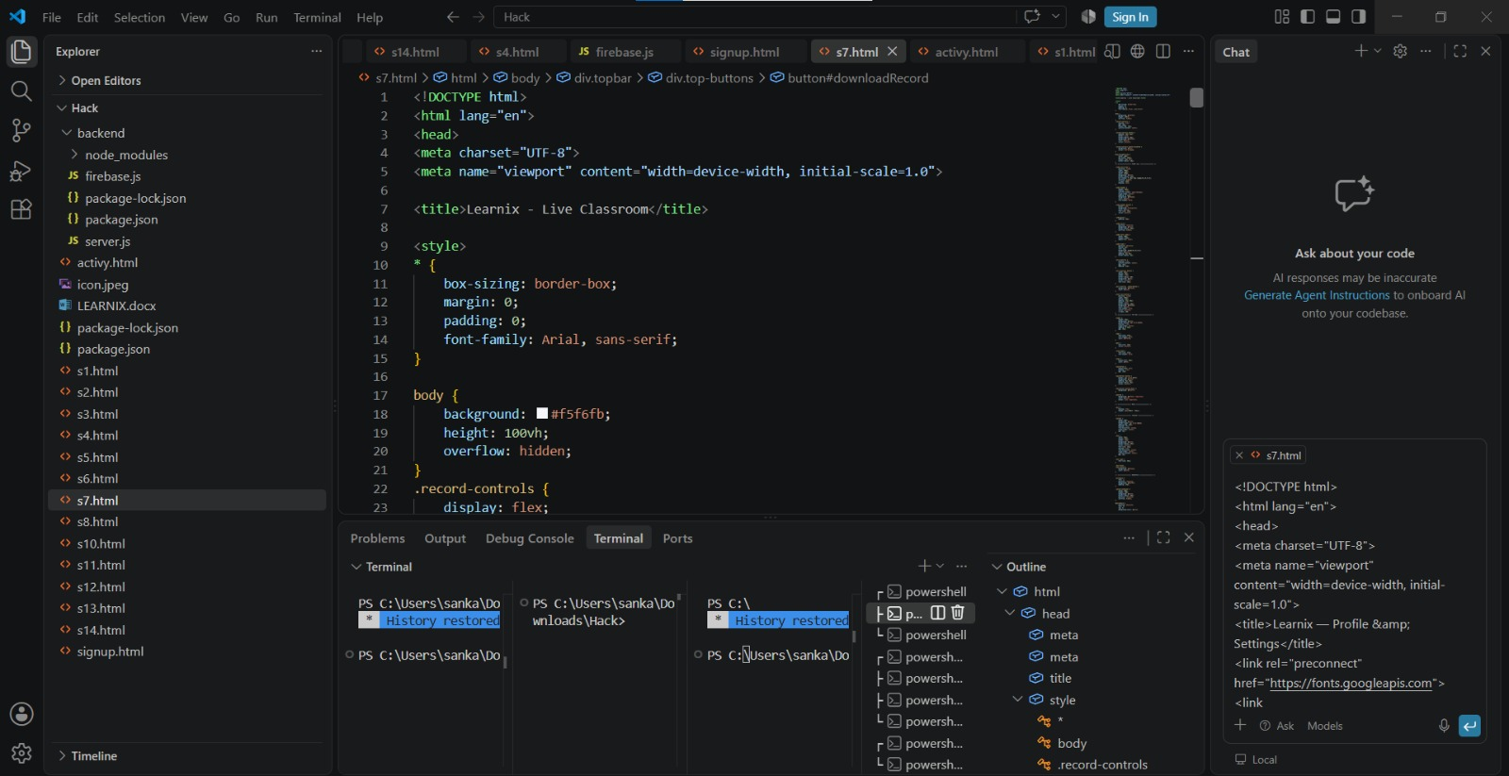

Admin Dashboard:
